WDD 330 Final Web Application Proposal

Project Idea: My Plant Pal Tracker

Overview
“Plant Pal” is a website designed to help people care for their indoor plants more effectively. Many of us forget when to water or feed our plants, which can lead to their decline or death. This app addresses that issue by providing an easy way to monitor plant care. It offers straightforward reminders instead of complex guides, ensuring your plants remain healthy and you can enjoy having them as a hobby.

Target Audience
This app is for students and young adults (18–35) who are new to plant care. They want something quick and easy on their phone to keep plants alive without reading long articles or complicated books.

Major Functions
- Adding and Naming Your Plants: Quickly add a plant and give it a fun name (like “Leafy”).
- Identify My Plant: Snap a photo of a plant you don’t know. The app will tell you what it is and how to care for it.
- Setting Up a Care Schedule: Choose how often to water, feed, or rotate your plant (e.g., “Water every 8 days”).
- Automatic Reminders: The app reminds you when it’s time to care for your plant (e.g., “Time to water Leafy!”).
- Care History Log: Automatically see when you last watered or fed your plant.
- Help with Sick Plants: If your plant looks unhealthy (like yellow leaves), check for tips to help it recover.
- "What's Next" List: The home screen shows which plants need attention soon.
- Plant Fact Sheet: Keep basic care info for each plant (light, soil type) handy.
- Responsive Design: Adjusts well on phones, tablets, and computers.
- Fun Visual Effects: Smooth animations when switching pages or pressing buttons.

Wireframes
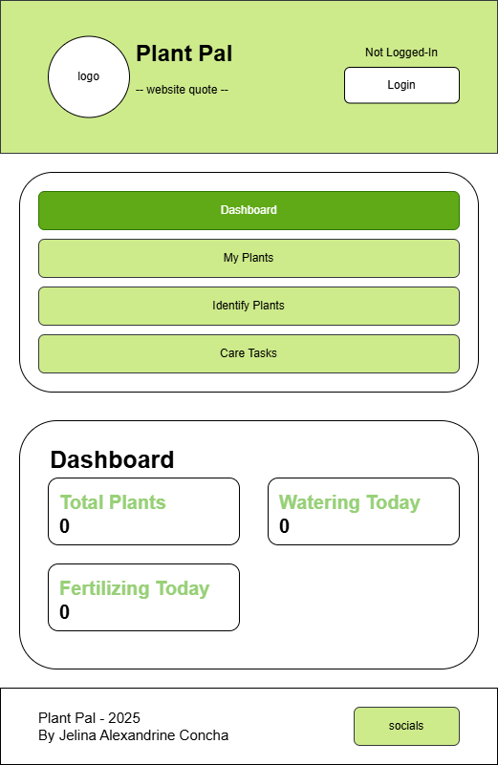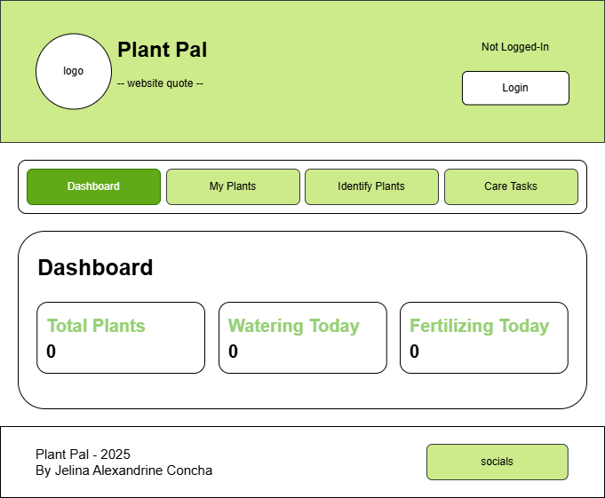

External Data
- Plant Identification Service: Used to analyze uploaded photos and return the species name and basic care needs.
- Database Service: Used to handle user logins, store all personalized plant data, and keep the care history secure.

Data Storage
- User Profiles (Email, Password, ID): To let people log in and keep their plant data separate and private.
- Plant Records (Name, Photo, ID number): To save the custom information and look up the official care rules for each plant.
- Care Schedules (How often, Next Date): To run the reminder system and know when tasks are due.
- History Log (Action, Time): To track when tasks were completed and show the full care timeline.

Module List
- Home Page Module: Sets up the main dashboard view and directs the user to different parts of the app.
- Plant Identification Module: Manages the connection to the external plant identifying tool and processes the plant data it sends back.
- Plant Management Module: Handles saving, updating, and deleting plant records, along with managing the care history log.
- Scheduling & Notification Module: Contains the logic that figures out the next due date for care tasks and shows the reminders.
- User Authentication Module: Handles creating accounts, logging in, and keeping the user session secure.
- Diagnostic Module: Manages the "Help with Sick Plants" feature and provides solutions for plant problems.
- Responsive Layout Module: Contains the code that makes sure the website looks right on different screen sizes (part of Major Function 9).

Graphic Identity

Color Palette:
- Primary: #043915 (Dark Green)
- Secondary: #B0CE88 (Sage Green)
- Neutral: #FFFD8F (Pastel Yellow)
- Warning Color: #FFB30E (Spanish Yellow/Orange)
- Text Color: Black & White

Typography:
- Heading: "Quicksand"
- Body: "Roboto" (Sans-serif)

Icon Design:
A simple picture of a small potted plant in a terracotta pot.
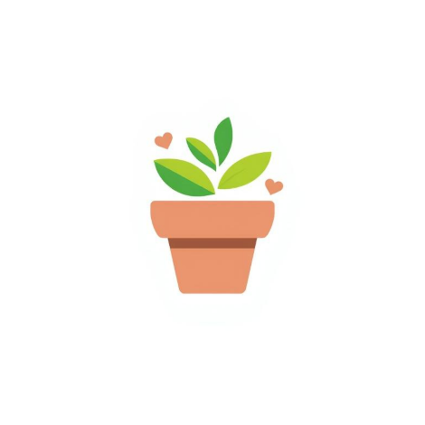

Timeline (Week 5-7)
Week | Work I Plan to Do | What Will Be Finished (Deliverable)
Week 5 | Plan everything (using Trello), set up login/signup pages, and create a basic design. | Live login/logout pages. The ability to save a new plant name and user ID to the database.
Week 6 | Add plant ID feature, care schedule logic, and plant details page. | The plant ID lookup works (the photo returns data). The app shows the next date a plant needs care.
Week 7 | Connect the schedule to the dashboard, finish “Help with Sick Plants,” test on all devices, and add animations. | The entire app is fully functional, fulfills all 10 goals, and displays well on all devices. Final testing is finished.

Project Planning
https://trello.com/invite/b/692ae8b7b44f508b9d1777cc/ATTI85c9302b5ee1617eea4fd29345c36461ECBBA05B/wdd330-final

